Republicans and Democrats have dramatically shifted their views of the US economy since the election 

The way Americans view the economy has undergone a dramatic shift in the week since Donald Trump was elected president of the United States.

Gallup’s Economic Confidence Index, based on an average of how Americans view current economic conditions, registered a large shift among both self-identified Democrats and Republicans over a week time period following Election Day.

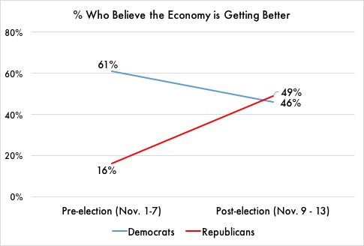 “Republicans have had a dismal view of the economy — especially of its future direction — during President Barack Obama’s two terms,” said the release from Gallup. “We now see Democrats becoming more pessimistic about the economy under a Republican president.”

In fact, the proportion of Republicans saying the economy is getting better improved from 16% in the preelection period to 49% after Trump was elected. For Democrats, it did the opposite, falling from 61% to 46%.

*Both Republicans and Democrats shifted their views immediately following Trump’s election. Source: Gallup Polls, Nov. 1-13, 2016.*

It is important to note that despite the huge swing in Gallup’s polling, economic conditions – including rates of unemployment, inflation, and wage growth – have not changed over the past few weeks.

Susan Thomas – a retired schoolteacher from Harrisburg, PA who voted for Donald Trump in 2016 —described Democrats’ views as “delusional.” “Can’t they see Trump is rescuing us from all the damage Obama did?” Her neighbor, Sandra Shelton, who voted for Hillary Clinton, had a very different view. “Trump is just benefitting from Obama’s economy,” she said. “Republicans are crazy if they don’t get that.”

President Trump has frequently touted the economy’s performance under his administration, often tweeting out reports of the stock market hitting new highs. The White House has also balked at suggestions that former President Obama is responsible for the current state of the economy.